HW10 ECE 40400



Special Buffer Overflow String AAAAAAAAAAAAAAAAAAAAAAAAAAAAAAAAAAAAAAAA\x18\x0e\x40\x00

Determining the Special String

I followed the instructions in Lecture 21 starting at page 43 to determine the string and I will briefly go through the steps I used as the process for this homework is slightly different than the example given. I compiled the server code and then opened the executable in gdb. Then I disassembled the secretFunction to locate the first memory address to enter into the object code for this function. When we overwrite the return address of the clientComm stack frame we want it to be overwritten with this memory address to enter the secret function. We only needed to use the last four bytes of the address. Then I disassembled the clientComm function and found the address of the “leaveq” assembly function so that I could set a breakpoint at that specific address. Then I ran the code with the port being 9000. I opened another terminal and compiled the client.c file and ran the executable as ./client 127.0.0.1. Then I was prompted to to type in a string and I entered 10 A's. Going back to the server terminal it had stopped at the specified breakpoint. Then I used print /x *((unsigned *) $rbp + 2) to see the return address of the stack frame and used x /48b $rsp to see the first 48 bytes of the stack frame being pointed to by the stack pointer. I could see the hex values of the 10 A’s and looking at the return address of the stack frame I was able to count how many A’s would need to be sent to where I could append the reverse of the last four bytes of the first memory address in the secretFunction to overwrite the return address of the stack frame. Then I went back to the client terminal and inserted the string. Going back to the server terminal I could see the secretFunction had been entered as the print statement had been called from the function as seen below.

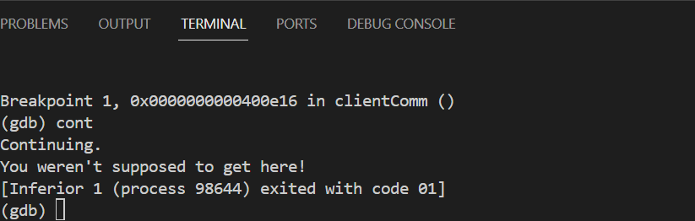

Fix to server.c

I simply used strncpy instead of strcpy so that I could specify at most n characters to be copied where n is the MAX_DATA_SIZE. This ignores all other characters after the MAX_DATA_SIZEth character. A screen shot of a computer program

The image below also shows that even though the special buffer overflow string was sent the first five As are all that was copied so the buffer overflow attack doesn’t occur anymore. Before hand the “You Said:” contained 40 As with the @ symbol afterwards.

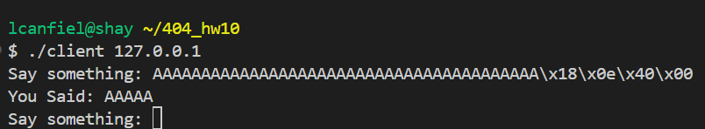

Page worth of Log Contents

New message log:1

procmail: Couldn't determine implicit lockfile from "/usr/sbin/sendmail"

From lcanfiel@purdue.edu Thu Apr 4 10:20:14 2024

Subject: Email Test

Folder: /usr/sbin/sendmail -oi lcanfiel@purdue.edu 6155

New message log: 2

From bounces+8143873-a96e-ece404e1=ecn.purdue.edu@u8143873.wl124.sendgrid.net Thu Apr 4 10:38:40 2024

Subject: =?UTF-8?B?WW914oCZcmU=?= now signed up to Down to Earth

Folder: spamFolder 68759

New message log: 3

From bounces+8143873-a96e-ece404e1=ecn.purdue.edu@u8143873.wl124.sendgrid.net Thu Apr 4 10:38:41 2024

Subject: =?UTF-8?B?WW914oCZcmU=?= now signed up to First Thing

Folder: spamFolder 69088

New message log: 4

From bounces+8143873-a96e-ece404e1=ecn.purdue.edu@u8143873.wl124.sendgrid.net Thu Apr 4 10:38:41 2024

Subject: Welcome to Well Actually

Folder: spamFolder 68839

From bounces+8143873-a96e-ece404e1=ecn.purdue.edu@u8143873.wl124.sendgrid.net Thu Apr 4 10:38:40 2024

Subject: =?UTF-8?B?WW914oCZcmU=?= now signed up to Margaret Sullivan's

Folder: spamFolder 69367

From bounces+8143873-a96e-ece404e1=ecn.purdue.edu@u8143873.wl124.sendgrid.net Thu Apr 4 10:38:40 2024

Subject: =?UTF-8?B?WW914oCZcmU=?= now signed up to Robert Reich's newsletter

Folder: spamFolder 69098

From bounces+8143873-a96e-ece404e1=ecn.purdue.edu@u8143873.wl124.sendgrid.net Thu Apr 4 10:38:40 2024

Subject: =?UTF-8?B?WW914oCZcmU=?= now signed up to Soccer with Jonathan Wilson

Folder: spamFolder 69552

From bounces+8143873-a96e-ece404e1=ecn.purdue.edu@u8143873.wl124.sendgrid.net Thu Apr 4 10:38:40 2024

Subject: =?UTF-7?B?WW914oCZcmU=?= now signed up to Trump on Trial

Folder: spamFolder 68795

New message log: 5

From bounces+8143873-a96e-ece404e1=ecn.purdue.edu@u8143873.wl124.sendgrid.net Thu Apr 4 10:39:56 2024

Subject: Welcome to Reclaim Your Brain

Folder: spamFolder 74194